Chapter 2

Introduction to the
C++
Programming Language

C++ is a high-level language (HLL) developed from the C language by Bjarne Stroustrup in 1979 at Bell Laboratories. It is implemented on different Operating Systems such as UNIX and Windows. C++ was initially standardized in 1998 by the International Organization for Standardization (ISO). The latest standard version was approved and published by ISO in December 2020 as ISO/IEC 14882:2020 (informally known as C++20). Besides the standard definition of C++ (ISO C++) there are many C++ implementations such as Turbo C++, Microsoft C++, and DEV C++. The latter is the one considered in this material as long as it complies with the standard implementation whenever possible.

2.1 Implementing a C++ Program

To write a program in C++ the C++ system must be available. This system includes an editor, a compiler, and other utilities. All of these components can be accessed through what is called the Integrated Development Environment (IDE). From within IDE programmers can edit, compile, debug, and run their programs. The editor is used for editing the program text. Also, it enables the programmer correct typing errors, load saved programs, save new programs, print programs and so on. In addition, it affords some word processors’ features such as copy/cut and paste, find and replace, and opening more than one program at a time.

A program written in an HLL such as C++ consists of a sequence of statements expressed in English, which is convenient to the programmer. This program is called the source program (code). It is entered to the computer through the keyboard. But the computer’s processor needs the program it is going to execute to be expressed in a language that it can understand. This language is called Low-Level Language (LLL) or machine language. An LLL program consists of a sequence of simpler instructions, previously known to the processor, expressed in 0’s and 1’s. It is called the executable program (code). The process of translating a source code into its equivalent executable code is too complicated to be gone through by humans. Fortunately, two system programs known as the “compiler” and the “linker” carry out this process.

Each HLL implementation has its own compiler and the same applies to C++. Thus a program written on paper as text is entered to the computer through the editor. Then the edited program (source program) is input to the compiler to produce a low-level language code written in 0’s and 1’s. This is called the object code (file). The object file cannot execute, as it needs to be linked to some other complementary object files. The linker performs this task to produce an executable program. The executable program is ready to run in order to produce the required output. This process is shown in figure 2.1.

Program text

Output
Input data
Editor
Source Code

Fig 2.1 the process of implementing a C++ program

Object File

Compiler

Executable File

Complementary Object Files

Linker

Execution

In the compilation phase the compiler may encounter some errors called syntax errors. The source of this kind of errors is that some part of the program does not comply with the rules of the C++ language. In this case the compiler interrupts the compilation process and returns to the IDE with an error message. After fixing a syntax error the compilation process should be gone through until no syntax errors are detected. As the program becomes free of syntax errors its executable code can be generated and run.

In running the executable program another kind of errors called run-time error may be detected (based on the implementation). If this is the case, the program is interrupted and the system returns to the IDE.

A program free of syntax errors and run-time errors may not output the required results. The error in the output is called logical error. The reason may be a mistake in writing the algorithm or in converting the algorithm into program. To detect the existence of logical errors it is recommended to test the program. This means running the program with different sets of input data with known output results.

2.2 What is Syntax?

The syntax of a programming language is analogous to the grammar of natural languages, which is defined by vocabulary and sentence structure. In programming languages the vocabulary is called reserved words and the sentence structure is the statement format. To make it clear, a reserved word is a word that has a predefined meaning, use, and spelling. Therefore, the reserved words must be written as they are and used as they should; taking in consideration that C++ is case sensitive. Also, as any natural language, the C++ makes use of letters, digits, and some special symbols. The following is a list of the reserved words in addition to the letters, digits, and special symbols used by C++.

Reserved Words

and | delete | if | register | true
asm | do | inline | reinterpret_cast | try
auto | double | int | return | typedef
bool | dynamic_cast | long | short | typeid
break | else | mutable | signed | typename
case | enum | namespace | sizeof | union
catch | extern | new | static | unsigned
char | explicit | not | static cast | using
class | false | operator | struct | virtual
const | float | or | switch | volatile
const_cast | for | private | template | wchar_t
continue | friend | protected | this | while
default | goto | public | throw

Letters

A | B | C | D | E | F | G | H | I | J | K | L | M
N | O | P | Q | R | S | T | U | V | W | X | Y | Z
a | b | c | d | e | f | g | h | i | j | k | l | m
n | o | p | q | r | s | t | u | v | w | x | y | z

Digits 0 1 2 3 4 5 6 7 8 9

Special Symbols

; + - , = : / # ~ ? ! > < != >= <= == * % & | _ ^ . [ ] ( ) { } ‘

/* */ && || >> << “ ++ -- += -= *= /= ^= &= %= |= :: ->

2.3 Structure of a C++ Program

A typical C++ program consists of a preprocessor directive, declaration part, and a main function. In addition, comments are allowed in different parts of the program.

Preprocessor Directive
Global Declarations part;
Main Function

2.3.1 Preprocessor Directive

The preprocessor is a program that runs before the compiler to prepare the program for compilation. The preprocessor searches the source code for the preprocessor directives (lines that begin with the pound symbol '#') and acts on them prior to the compilation phase.

The building blocks of a C++ program are functions. A function is a piece of code (small program) that when executed performs a specific task. The functions that are provided by the C++ system are called “standard functions.” These functions are grouped, according to some criteria, in files called “header files.” A preprocessor directive, called the 'include' directive, is used to inform the preprocessor of the files that contain the function(s) that the program is going to use.

The “include” directive directs the preprocessor to find the specified header file and include it in the program. The syntax of the “include" directive is:

# include <header file name>

A separate “include" directive must be used for each header file if more than one are going to be specified.

2.3.2 Global Declarations

These declarations include, among others, constant definition and type definition. Each of these definitions will be explained later. A program may or may not contain one or more of these definitions.

2.3.3 The “main” Function

Any C++ program starts execution at a function called “main”, it is the function that contains the program statements and the calls to the other functions. The function declaration includes a function heading followed by a function body. The function heading takes the form:

int main ()

It starts with the reserved word "int" followed by the function name, which is “main” followed by (). Throughout this material reserved words will be written in boldface. Reserved words must be written as they are. For example, the word "Int" is invalid in place of “int” because “I” is uppercase. The word “main” is the name of the function. Names in C++ terminology are called identifiers.

Identifiers in C++ are either pre-defined or user-defined. Predefined identifiers are part of the C++ system. Each of them has a specific use in C++ programs. They may represent constants, data structures, and functions. In this text predefined identifiers are written in italic. C++ is also “case sensitive” with identifiers. So, the word “Main” is not the name of the “main” function.

A user-defined identifier is constructed according to the following rules:

- Must begin with a letter or an underscore ‘_’.
- The following characters can be letters and/or digits.
- Must not contain any special characters except the underscore.
- Must not be a reserved word.
- Must not be declared more than once (in the same block).

Examples of valid identifiers:

AUC
ThisIsAnIdentifier
A2z

Examples of invalid identifiers:

int | Reserved word
This IsAnIdentifier | Contains a space
3M | Starts with a digit
prog.exe | Contains a period

The main function body is enclosed between “{“ and “}”. It consists of a declaration part and a statement part. The declaration part may be thought of as the data table of the program. It contains the types and names of the variables to be used in the program. The program statements appear in the statement part in the order of execution separated from each other by semi colons “;”.

{
Declaration part;
Program statements separated by semi colons
}

2.3.4 Comments

Comments are not part of the problem solving process. But they are used as remarks or notes to explain the different parts of the program for the sake of tracing and/or modifying the program. Efficient use of comments makes the program to be self-documented, easy to trace, and easy to modify. Comments are totally ignored during the compilation phase; so they have no effect on the program execution. Comments are text enclosed between "/*" and "*/" or preceded by "//" as follows:

/* This is a multiple
line comment */

// and this is a single line comment.

2.4 Starting C++

In order to get acquainted with programming in C++ the rest of this chapter will present some solved examples. Through these examples, straight-line programs that use variable and constant declarations, numeric and alphanumeric variables and types, input, output, and assignment statements will be explained.

Example 2.1

Write a C++ program to calculate and print the sum and average of two numbers.

# include <iostream> /* input from the keyboard and output on the screen */

using namespace std; /*Information about cin & cout */
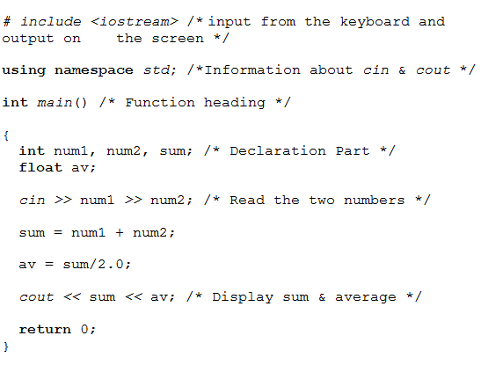
The # include directive specifies the iostream header file. This file contains the functions that perform the input and output operations (input from the keyboard and output on the screen).

The variable declaration part contains a definition of all the variables to be used in the program. Each variable is defined by a type and name (identifier). If more than one variable have the same type, they can be grouped in a list of identifiers separated by commas. The variable declaration starts with the list type followed by a list of variable identifiers, and a “;”

List type list of variable identifiers;

Each variable must be declared prior to its use. The variable identifier is the name used to reference the variable in the program. The variable type specifies its range of values, the memory size it requires, and the valid operations to be performed using it. It is essential to consider the variable specifications when selecting its type. In the previous examples the int and float types have been used. Both types will be explained in more details in the following sections.

int data type

Variables of the type “int” hold integer values. Integer values are whole numbers; fractions are not allowed. A variable of the type “int” requires 2- 4 bytes of memory (based on the computer). The value of the variable may be positive or negative. An int variable can be read, written, assigned a value, used in calculations, and compared to numeric values or variables. The following table shows the arithmetic operators and operations that are allowed using int values and/or variables.

Operator | Operation | Example | Result
+ | addition | 5 + 6  -5 + 7 | 11  2
- | subtraction | 100 - 64  20 - 23 | 36  -3
* | multiplication | 12 * 6  2 * -10 | 72  -20
/ | integer division  (truncated division) | 13 / 3  -8 / 4  2 / 6 | 4  -2  0
% | modulus  (remainder of the division operation) | 11%7  3 % 5  5 % 3  5 % -3  -5 % 3  -5 % -3 | 4  3  2  2  -2  -2
++ | Increment by 1 | X = 5; X++; | X is 6
-- | Decrement by 1 | X = 5; X--; | X is 4

float data type

Also float variables hold numeric values but they may contain fractions. A variable of type float occupies 4 bytes of memory. It could be positive or negative. The float values range from 3.4E-38 to 3.4E+38. A float variable can be read, written, assigned a value, used in calculations, and compared to numeric values or variables. The following table shows the arithmetic operators and operations that are allowed using float values and/or variables.

Operator | Operation | Example | Result
+ | addition | 5.5+6.3 | 11.8
- | subtraction | 10.0-6.4 | 3.6
* | multiplication | 2.2*6.5 | 14.3
/ | division | 13/4 | 3
/ | division | 13 / 4.0 | 3.25
++ | Increment by 1 | X = 5.1; X++; | X is 6.1
-- | Decrement by 1 | X = 5.1; X--; | X is 4.1

2.4.2 Statement Part

The statement part starts after the end of the variable declarations. It consists of the program statements separated from each other by semi colons “;” and terminated with a right brace “}”. The previous program body includes five statements: one cin statement, two assignment statements, one cout statement and one return statement.

cin Statement

The first statement of the statement part is the cin (pronounced C- in) statement. It accepts input data from the keyboard at run-time and stores it in the specified variable(s). The use of the cin statement resembles the use of the read step in algorithms. The syntax of the cin statement is as follows:

cin >> input variables separated by “ >>”

At run time the computer waits for the corresponding values to be entered. The values are entered via the keyboard separated by spaces. The first value is stored in the first variable in the input variables’ list; the second value is stored in the second variable and so on. Therefore these values must be type-matched with the specified input variables’ list in one-to-one correspondence. As a type-matching rule, int values can be used wherever float values are expected but the reverse is invalid. In case of any discrepancy incorrect result will take place. After the values have been entered the “enter key” should be pressed.

Assignment Statement

The second and third statements of the statement part are assignment statements. The assignment statement is equivalent to the replacement step in algorithms. It assigns (stores) a value to a variable. The following is the syntax of the assignment statement.

Variable identifier = value;

The symbol “=” is called the assignment operator. The value on the right-hand side of the assignment operator is assigned to the variable on the left-hand side. The value on the right-hand side may be presented as value, variable, or expression. In all cases both sides must be type-matched otherwise unexpected result will show. It is worth mentioning that the values of the variables on the right-hand side remains unchanged after the execution of the assignment statement. The following are variations of an assignment statement.

x = 5; // x takes the value 5 (1)
y = x; // y takes the value stored in x which is 5 (2)
z = y*3; // z takes the value of the expression y*3 which is 15 (3)
z = z+1; // z takes the value of the expression z+1 which is 16 (4)

In the fourth statement the variable “z” is used in both sides. First, the system evaluates the expression on the right-hand side using the old value of “z” which is 15. Then the calculated value (15+1) is stored in the variable on the left-hand side which is also “z.” As such, the value of “z” is changed as a result of being used on the left-hand side.

Arithmetic Expression

The variable “z” in the third and fourth statements has been assigned the value of an arithmetic expression, which is a piece of calculation. In general, an arithmetic expression is a collection of values and/or variables joined with arithmetic operators. The value of the expression is evaluated according to a rule called the “precedence rule.” According to this rule, C++ operators have the following priorities with 3 is the highest and 1 is the lowest. Associativity indicates the direction of calculation in case of the expression includes more than one operator of the same priority.

priority | Operator | Associativity
4 | () | Left to right
3 | Unary minus | Right to Left
2 | * / % | Left to right
1 | + - | Left to right

The following points should be considered when using arithmetic expressions:

- Nested parentheses are evaluated on in-out basis. In other words, the inner most parenthesis is evaluated first.

- Operators with the same priority are evaluated according to their associativity.

- The multiplication operator must not be omitted, e.g., AB is invalid for A times B and it must be written A*B.

- It is recommended to use parentheses when in doubt with the precedence rule as using redundant parentheses is not harmful.

The following are some examples that illustrate the precedence rule in evaluating arithmetic expressions.

Expression | Result
3*17 –193 % 19 | 48
193 % 19 / 3*127 | 127
193 % (19 / 3)*127 | 127
(4 + 23*-2) / 3 | -14
(37+15 % 4)/(5*5.0) | 1.6
(37+15 % 4)/ 5*5 | 40

cout Statement

The purpose of using the cout (pronounced C- out) statement is to display data items. The following is the syntax of the cout statement:

cout << output data items separated by “<<”

The data items to be displayed could be values, variables, function calls, character strings, escape sequences and expressions. When displaying numeric values they are specified as they are. Specifying a variable in a cout << statement results in displaying its contents. Examples of the cout << statement are illustrated below considering two variables x & y of type int and hold the values 3 & 5 respectively.

Statement | Display
cout << x; | 3
cout << x <<y; | 35
cout << x+y; | 8
cout <<“x+y”; | x+y
cout << “x=” << x; | x=3
cout <<“x = ”<< x; | x = 3
cout <<“x = “<<x << “ y = ”<<y; | x = 3 y = 5
cout <<10; | 10
cout << “10”; | 10

The character string, which is a sequence of characters is used as follows:

cout << “ This is a character string; it will be displayed as it is”;

The escape sequence, which is a backslash ‘\’ followed by a character, is used for outputting some special characters. A list of the most frequently used escape sequences is shown in the following table:

Sequence | Output
\a | Bell
\n | New line
\\ | Backslash
\’ | Single quote
\” | Double quote
\? | Question mark

The following table illustrates some examples of using the cout statement using character string some escape sequences.

Statements | Display
cout << ”Hello World” | Hello World
cout << ”Hello ” ;  cout << ”World” ; | Hello World
cout << ”Hello \n World” | Hello  World
cout <<”Hello\n”<< “World” | Hello  World
cout << ”Hello \n” ;  cout << ”\nWorld” ; | Hello  World

Enhancing the appearance of the program running is mainly the job of the programmer. One of the methods of achieving this is to use user-prompted messages. These messages guide the user throughout the running phase. They inform the user of what to be entered and what is being displayed. Therefore, each cin>> statement is always preceded with a message to prompt the user for the values to be entered. Also, each displayed value is always associated with its description. A user-prompted message is simply a quoted text (character string) in a cout <<statement as follows:

cout <<” This is a user prompted message”;

User prompted messages must be meaningful, so it is advisable to avoid using variables’ names or technical terms. For example, if the user is required to enter two numbers which of the following messages is better to be used:

cout << “Enter two variables: ”;
cout << “Enter X1 and X2: ”;
cout << “Enter two numbers: ”;

It is clear that the third message is the most appropriate.

return statement

The last statement of the program is the return 0 statement. It is used to show whether the program has normally terminated or not.

Example 2.2

Solve example 2.1 using user-prompted messages when necessary to enhance the appearance of the program running.

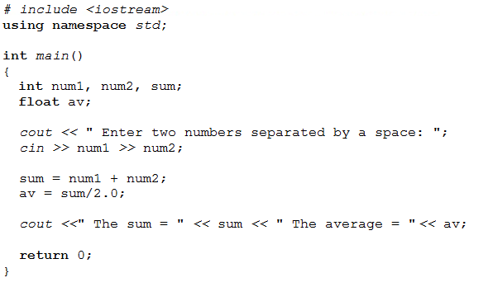
Example 2.3

Write a C++ program to read the radius of a circle and calculate and print its area provided that the constant pi = 3.14159.

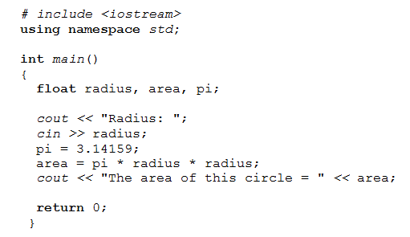

Example 2.4

Write a C++ program to compute the time and cost of an auto-trip using the following formulas:

(1) Time = Distance / Speed.

(2) Gallons of gas used = Distance / kms per gallon.

(3) Cost of the trip = gallons used X cost per gallon.

Provided that the cost per gallon is L.E 160.

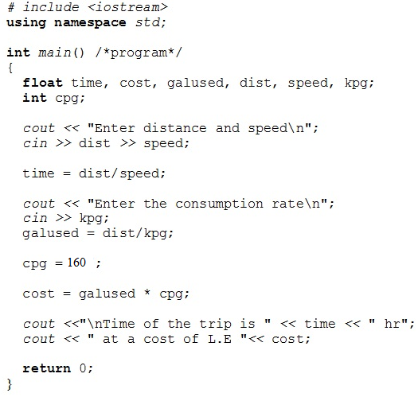
2.4.3 Constant Declaration

The C++ system provides a set of standard constants that programmers can directly use without declaration (some of them will be mentioned in chapter 6). Constants are used to denote two categories of values. The first is the values that never change such as the value of pi, light speed, number of days in a week, color codes in the text mode (0 to 15), number of bits in a byte (8), number of bytes in KB (1024) and so on. The latter is the values that are rarely altered. These values are given in the problem phrasing and do not change throughout the program such as tax rate, maximum number of employees, minimum number of students, and so on.

C++ allows the programmers to declare what is called “user-defined constants.” These constants are declared as follows:

/*Preprocessor Directive*/

const type constant identifier = value;

/*Function main*/

Where the word const is a reserved word, the type is any valid C++ type, the constant identifier is any valid C++ identifier and the value is either numeric or alphanumeric according to the specified type. Constants of the same type are separated by commas. The following is a sample of numeric constant declarations.

const float TaxRate = 0.07;

const int Max = 100, Min = 20;

A constant is simply a value given a name. Therefore, constants are allowed to be displayed, compared, and used in calculations. Their values are not allowed to be changed in the program.

cin >> TaxRate; /* invalid */

cout << Max; /* valid */

Max = 100; /* invalid */

Example 2.5

Solve example 2.3 declaring constant pi as user defined constant.

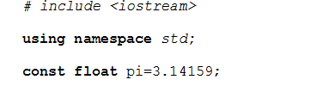
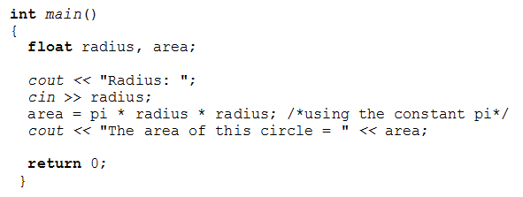
The programs that have been written so far manipulated only numeric variables of the types int and float. In real life applications the nature of data necessitates the existence of other types that can deal with alphanumeric values in order to store names, addresses, students letter grades, etc. C++ supports the char data type to deal with such data.

char data type

In many situations useful information can be presented using only one character. For example, ‘M’/’F’ to represent gender, ‘P’/’F’ for Pass and Fail, and ‘S’/’M’ is sufficient for expressing marital status. In these situations the C++ data type char can be used. A char variable can hold only one character. It needs only one byte of memory. These variables are read by a cin statement. Also, they can be assigned values using an assignment statement. The value assigned to a char variable must be quoted using single quotes ’ & ’. Also, char variables/values can be displayed using cout statement, and compared to other alphanumeric values/variables. The variables of the type char are declared as follows:

char variable identifiers list;

Character Strings

When need arises to store data such as names and addresses, variables of the type char become insufficient. The character string solves this problem. Character string variables are declared as follows:

string variable identifier ;

String variables are read using a cin statement, assigned values by an assignment statement. The value assigned to a string variable must be quoted using double quotes “ and. “ Also, character string variables/values can be displayed using cout statement and compared to character string values/variables.

The following group of statements illustrates the declaration and use of the char and string data types.

# include <iostream>
using namespace std;

int main ()
{
char ch1,ch2, A, B, C;
string First, Mid, Last, Address;

cin >> ch1; /* ch1 is entered by the keyboard */

ch2 = ch1; /* the value of ch1 is copied to ch2 */

cout << ch1<< " "<< ch2; /* the values of ch1 and ch2 are displayed separated by a space */

A = ’$’; /* the $ is stored in A */

B = A; /* B takes the value stored in A, which is $ */

C = ’A’; /* the character A is stored in C */

cout << A<< B<< C; /* $$A is displayed */

cin >> First >> Mid >> Last; /* First, Mid, Last are entered through the keyboard */

Address = "28 Falaky street, Bab El-Louk, Cairo";

//A string constant is assigned to the variable 'Address'

cout << First << " " << Mid << " "<< Last << " \nstudies at " << Address;

return 0;

}

At run time the entered values must be type-matched as specified in the cin statement in one-to-one correspondence. In case of any discrepancy i.e. if more than one character were entered for a char variable no run-time error will take place; but only the first character would be considered and the rest would be omitted. After the values have been entered the “enter key” should be pressed.
Example 2.6

Write a C++ program to read the name, basic salary and the overtime hours of an employee and compute the employee's net salary as follows:

Net salary = Gross salary - Taxes
Gross salary = Basic salary + Payment from overtime
Taxes = Basic salary X Tax rate

Provided that the rate of overtime is L.E 35 per hour and the tax rate is 10%. The output of the program is the employee’s name and net salary.

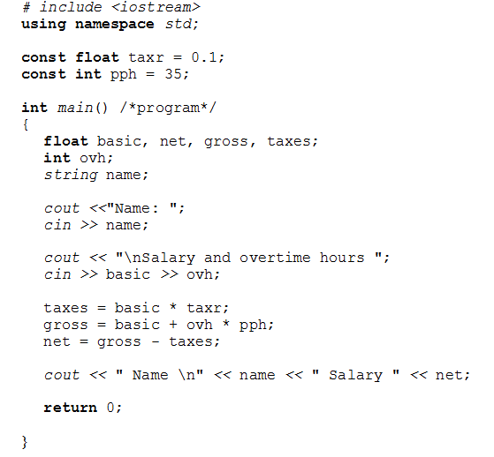

Problems

2.1 Write a C++ program to display the following right triangle:

*
**
***
****
*****
******
*******
********

2.2 Write a C++ program to display the following right angled triangle:

*
**
***
****
*****
******
*******
********

2.3 Write a C++ program to calculate and print the sum and average of three numbers.

2.4 Write a C++ program to read the price of a sweater, a jeans and a shirt and print the amount to be paid for 2 sweaters, a jeans and 3 shirts.

2.5 Write a C++ program to convert a temperature in degrees Centigrade C and print the corresponding equivalent on the Fahrenheit scale F using the following formula:

F = C x 9/5 + 32

2.6 Write a C++ program to exchange the values of two real variables x & y.

2.7 Write a C++ program to convert a period in hours into its equivalent days.

2.8 Write a C++ program to convert a period in hours into its equivalent days and hours.

2.9 Write a C++ program to convert a measurement in millimeters into its equivalent meters, centimeters, and millimeters. The output should be in the form: m: cm: mm. For example, a measurement of 3907 millimeters is displayed as: 3:90:7
2.10 Write a C++ program to calculate the area of a field in feddan given its width and length in meters (1 feddan = 4200 square meters.) using the following formulas:

- Field area in m² = Length X Width
(2) Field area in feddan = Field area in m² / Square meters in feddan

2.11 Write a C++ program to calculate the volume of a cylinder given its radius and height using the following formula:

Volume = 3.14 x radius ² x height.

2.12 A farmer has a field B meters wide, L meters long. The field yields C cubic meters grain per feddan (1 feddan = 4200 square meters). The farmer has a number of cylindrical grain silos (containers), R meters in radius, H meters in height in which he stores the harvest. Write a C++ program that calculates and prints the number of used silos using the following formulas:

(1) Number of used silos = Total harvest/ Volume of silo
(2) Total harvest = Field area in feddan X Yield per feddan.

2.13 At the beginning of a journey the reading on a car’s odometer is S kilometers and the fuel tank is full. After the journey, the reading is F kilometers and it takes L liters to fill the tank. Write a C++ program to calculate and print the rate of fuel consumption in Km/liter.

2.14 Write a C++ program to read the name of a student and four scores and print the student name and the sum of his/her scores.

2.15 Write a C++ program that prompts the user for his/her name, weight in pounds and height in inches, and computes his Body Mass Index (BMI). BMI is defined as the weight in kilograms divided by the squared height in meters. To convert from pounds to kgs multiply by 0.4536 and to convert from inches to meters multiply by 0.0254. The program is to display the user’s name and BMI.

2.16 A magnetic tape is L meters long, 1024 bytes/cm recording density and R cm/sec reading speed. Write a C++ program that outputs:

- The number of records that can be stored on the tape when the size of record is 512 bytes.

- The time taken to read the entire tape.

The concept of block will be explained in chapter 6.

